27. Bar Chart of Programming Language Popularity
Aim
To write a Python program to display a bar chart showing the popularity of different programming languages.
Code
import matplotlib.pyplot as plt

languages = ['Java', 'Python', 'PHP', 'JavaScript', 'C#', 'C++']
popularity = [22.2, 17.6, 8.8, 8, 7.7, 6.7]

plt.bar(languages, popularity)

plt.xlabel("Programming Languages")
plt.ylabel("Popularity")
plt.title("Popularity of Programming Languages")

plt.show()
Output
A vertical bar chart will be displayed with the six programming languages on the X-axis and popularity on the Y-axis.
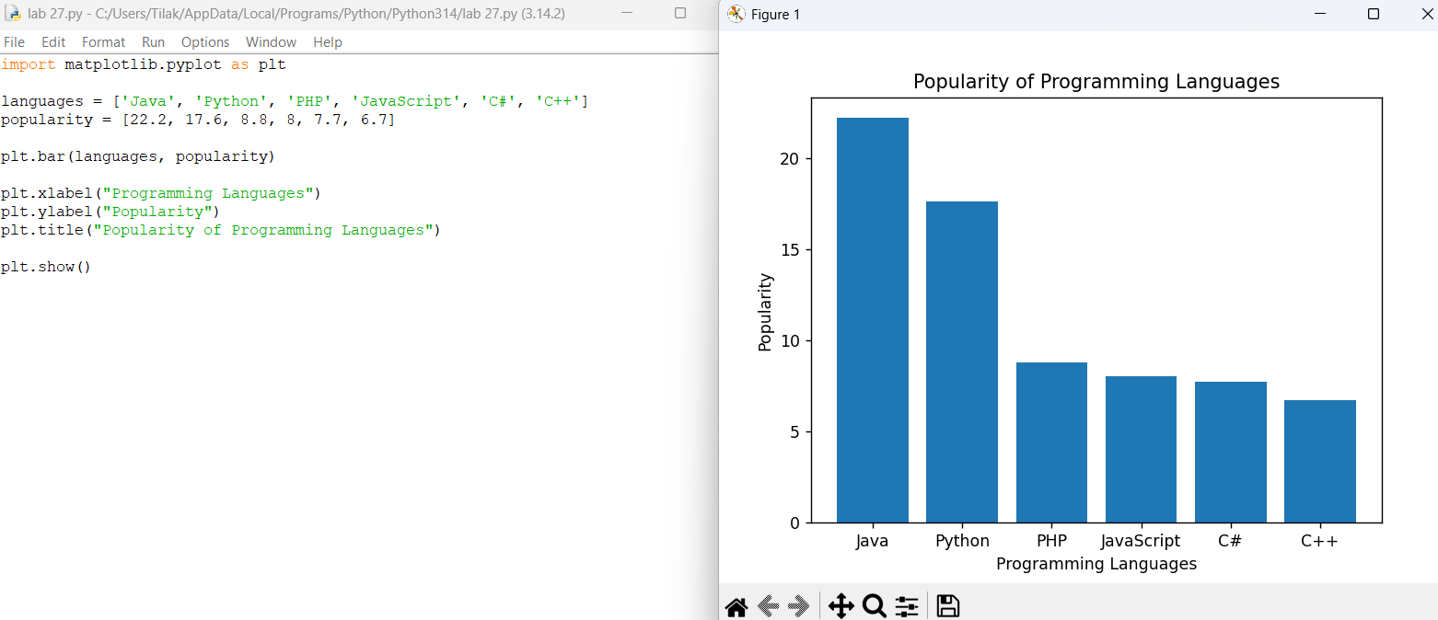
28. Horizontal Bar Chart
Aim
To write a Python program to display a horizontal bar chart showing the popularity of programming languages.
Code
import matplotlib.pyplot as plt

languages = ['Java', 'Python', 'PHP', 'JavaScript', 'C#', 'C++']
popularity = [22.2, 17.6, 8.8, 8, 7.7, 6.7]

plt.barh(languages, popularity)

plt.xlabel("Popularity")
plt.ylabel("Programming Languages")
plt.title("Popularity of Programming Languages")

plt.show()
Output
A horizontal bar chart will be displayed, with programming languages on the Y-axis.
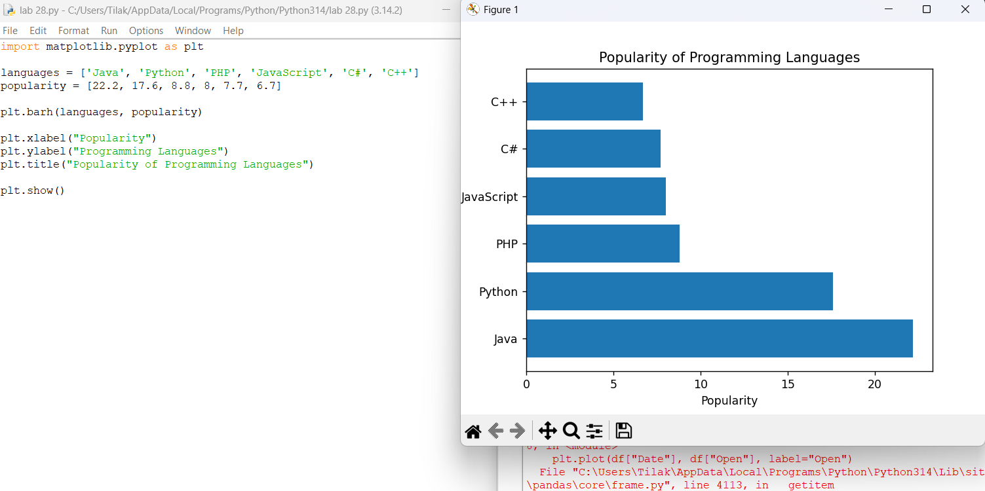
29. Bar Chart with Different Colors
Aim
To write a Python program to display a bar chart of programming language popularity using different colors for each bar.
Code
import matplotlib.pyplot as plt

languages = ['Java', 'Python', 'PHP', 'JavaScript', 'C#', 'C++']
popularity = [22.2, 17.6, 8.8, 8, 7.7, 6.7]

colors = ['red', 'blue', 'green', 'orange', 'purple', 'yellow']

plt.bar(languages, popularity, color=colors)

plt.xlabel("Programming Languages")
plt.ylabel("Popularity")
plt.title("Popularity of Programming Languages")

plt.show()
Output
A vertical bar chart will be displayed where each programming language has a different color.
